**DEPARTMENT OF INFORMATION TECHNOLOGY**

**COMPUTER COMMUNICATION AND NETWORKING LAB**

**LAB1: 11/1/2017**

**Objective**

• Identify tools used to discover a computer network configuration with various operating

systems.

• Gather information including connection, host name, Layer 2 MAC address and Layer 3

TCP/IP network address information.

• Compare network information to other PCs on the network.

**PC NETWORK AND TCP/IP CONFIGURATION**

**Step 1: Gather TCP/IP configuration information**

Use the Start menu to open the Command Prompt, an MS-DOS-like window.

Press **Start > Programs > Accessories > Command Prompt** or

**Start > Programs > Command Prompt**

The following figure shows the Command screen. Type ipconfig and press the

Enter key. The spelling of ipconfig is critical while case is not. It is short for IP

Configuration.

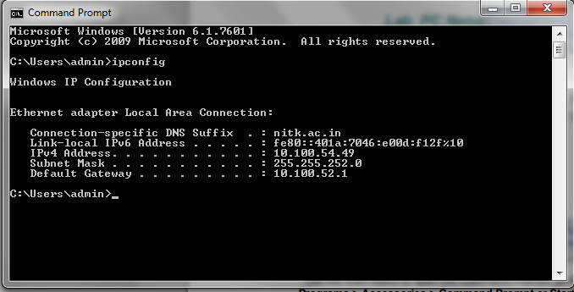

This first screen shows the IP address, subnet mask, and default gateway. The IP address and the default gateway should be in the same network or subnet, otherwise this host would not be able to communicate outside the network. In the figure the subnet mask tells us that the first three octets must be the same to be in the same network.

Note: If this computer is on a LAN, the default gateway might not be seen if it is running behind a Proxy Server.

**Step 2:** Record the following TCP/IP information for this computer

IPv4 address : 10.100.55.105

IPv6 address: fe80::7dd8:6db3:88b4:5aae%17

Subnet Mask: 255.255.252.0

Default Gateway: 10.100.52.1

**Step 3:** Compare the TCP/IP configuration of this computer to others on the LAN

If this computer is on a LAN, compare the information of several machines.

Are there any similarities? Yes. Same gateway and subnet mask. Initial part of the ip address is also the same.

What is similar about the IP addresses? The first 2 blocks of the ip addresses are the same.

What is similar about the default gateways? They are the same.

The IP addresses should share the same network portion. All machines in the LAN should share the same default gateway. Record a couple of the IP Addresses:

To see detailed information, type ipconfig /all and press Enter. The figure shows the detailed IP configuration screen.

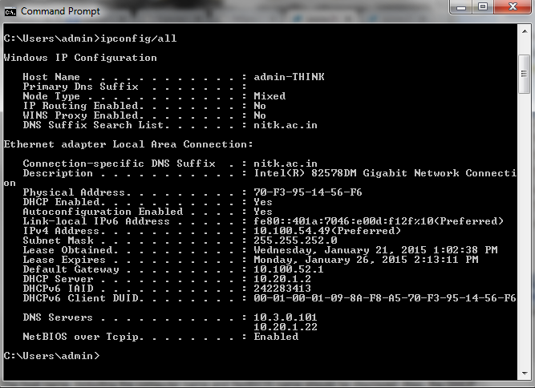

The host name, including the computer name and NetBIOS name should be displayed. Also, the DHCP server address, if used, and the date the IP lease starts and ends should be displayed. Look over the information. Entries for the DNS, used in name resolution servers, may also be present.

The previous figure reveals that the router is performing both DHCP and DNS services for this network. This would likely be a small office or home office (SOHO) or small branch office implementation.

Notice the Physical Address (MAC) and the NIC model (Description).

In the LAN, what similarities about the Physical (MAC) Addresses are seen?

-------------------------------------------------------------------------------------------------------------------------------

While not a requirement, most LAN administrators try to standardize components like NICs. Therefore, it would not be surprising to find all machines share the first three Hex pairs in the adapter address. These three pairs identify the manufacturer of the adapter.

Write down the IP addresses of any servers listed: _________________________

Write down the computer Host Name: __________________________________

Write down the Host Names of a couple other computers: ___________________

Do all of the servers and workstations share the same network portion of the IP address as

the student workstation? ______________________________________________

It would not be unusual for some or all of the servers and workstations to be in another network. It means that the computer default gateway is going to forward requests to the other network.

**Reflection**

Based on observations, what can be deduced about the following results taken from

three computers connected to one switch?

Computer 1

IP Address: 192.168.12.113

Subnet Mask: 255.255.255.0

Default Gateway: 192.168.12.1

Computer 2

IP Address: 192.168.12.205

Subnet Mask: 255.255.255.0

Default Gateway: 192.168.12.1

Computer 3

IP Address: 192.168.112.97

Subnet Mask: 255.255.255.0

Default Gateway: 192.168.12.1

Should they be able to talk to each other? _______________________

Are they all on the same network?____________________________

Why or why not? ____________________________________________

If something is wrong, what is most likely the problem? _______________

**USING PING AND TRACERT FROM A WORKSTATION**

Objective

• Learn to use the TCP/IP Packet Internet Groper (ping) command from a workstation.

• Learn to use the Trace Route (tracert) command from a workstation.

• Observe name resolution occurrences using WINS and/or DNS servers.

**step 1: Access the command prompt**

Windows NT / 2000 / XP users – Use the Start menu to open the Command Prompt window. Press Start > Programs > Accessories > Command Prompt or Start > Programs > Command Prompt or Start > All Programs > Command Prompt.

**step 2: ping the IP address of another computer**

In the window, type ping, a space, and the IP address of a computer recorded in the previous lab. The following figure shows the successful results of ping to this IP address.

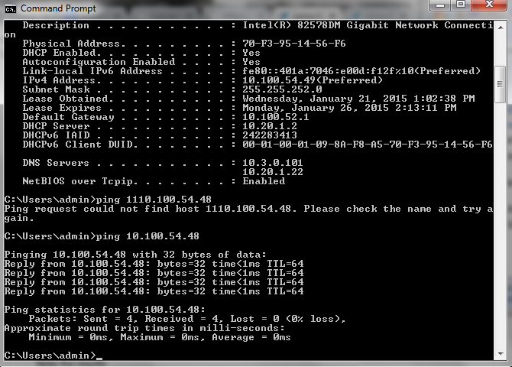

ping uses the ICMP echo reply feature to test physical connectivity. Since ping reports on four attempts, it gives an indication of the reliability of the connection. Look over the results and verify that the ping was successful. Is the ping successful? If not, perform appropriate troubleshooting.

If a second networked computer is available, try to ping the IP address of the second machine.

Note the results. _____________________________________________

**step 3: ping the IP address of the default gateway**

Try to ping the IP address of the default gateway if one was listed in the last exercise. If the ping is successful, it means there is physical connectivity to the router on the local network and probably the rest of the world.

**step 4: ping the IP address of a DHCP or DNS servers**

Try to ping the IP address of any DHCP and/or DNS servers listed in the last exercise. If this works for either server, and they are not in the network, what does this indicate?

____________________________________________________________

Was the ping successful? _______________________________________

If not, perform appropriate troubleshooting.

**step 5: ping the Loopback IP address of this computer**

Type the following command: ping 127.0.0.1

The 127.0.0.0 network is reserved for loopback testing. If the ping is successful, then

TCP/IP is properly installed and functioning on this computer.

Was the ping successful? _______________________________________

If not, perform appropriate troubleshooting.

**step 6: ping the hostname of another computer**

Try to ping the hostname of the computer that was recorded in the previous lab. Look over the results. Notice that the first line of output shows the host name, in the example, followed by the IP address. This means the computer was able to resolve the host name to an IP address. Without name resolution, the ping would have failed because TCP/IP only understands valid IP addresses, not names.

If the ping was successful, it means that connectivity and discovery of IP addresses can be done with only a hostname. In fact, this is how many early networks communicated. If successful, then ping a hostname also shows that there is probably a WINS server working on the network.

WINS servers or a local “lmhosts” file resolve computer host names to IP addresses. If the ping fails, then chances are there is no NetBIOS name to IP addresses resolution running. Note: It would not be uncommon for a Windows 2000 or XP networks to not support this feature. It is an old technology and often unnecessary.

If the last ping worked, try to ping the hostname of any another computer on the local network.

**step 7: ping the nitk website**

ping nitk.ac.in

The first output line shows the Fully Qualified Domain Name (FQDN) followed by the IP address.

A Domain Name Service (DNS) server somewhere in the network was able to resolve the name to an IP address. DNS servers resolve domain names, not hostnames, to IP addresses. Without this name resolution, the ping would have failed because TCP/IP only understands valid IP addresses. It would not be possible to use the web browser without this name resolution.

With DNS, connectivity to computers on the Internet can be verified using a familiar web address, or domain name, without having to know the actual IP address. If the nearest DNS server does not know the IP address, the server asks a DNS server higher in the Internet structure.

**step 8: ping the Microsoft web site and Cisco website**

Type the following command:

a. ping www.microsoft.com

b. ping www.cisco.com

Notice that the DNS server was able to resolve the name to an IP address, but there is no response. Some Microsoft and Cisco routers are configured to ignore ping requests. This is a frequently implemented security measure. Ping some other domain names and record the results.

**step 9: Type tracert www.cisco.com and press Enter.**

tracert is TCP/IP abbreviation for trace route. The preceding figure shows the successful result when running tracert from Bavaria in Germany. The first output line shows the FQDN followed by the IP address. Therefore, a DNS server was able to resolve the name to an IP address. Then there are listings of all routers the tracert requests had to pass through to get to the destination. tracert uses the same echo requests and replies as the ping command but in a slightly different way. Observe that tracert actually contacted each router three times. Compare the results to determine the consistency of the route. Notice in the above example that there were relatively long delays after router 11 and 13, possibly due to congestion. The main thing is that there seems to be relatively consistent connectivity.

Each router represents a point where one network connects to another network and the packet was forwarded through.

**step 10: trace route other IP addresses or domain addresses and record the results**

**step 11: Trace a local host name or IP address**

Reflection

If the above steps are successful and ping or tracert can verify connectivity with an Internet

Web site, what does this indicate about the computer configuration and about routers between

the computer and the web site?______________________________________________

What is the job of default gateway? ______________________________